***Dt : 13/5/2022***

***Assignment:(Solution)***

***wap to read two int values and perform arithmetic operation based***

***on User choice:***

***1.add***

***2.sub***

***3.mul***

***4.div***

***5.modDiv***

***Addition.java***

***package p2;***

***public class Addition {***

***public int add(int x,int y)***

***{***

***return x+y;***

***}***

***}***

***Subtraction.java***

***package p2;***

***public class Subtraction {***

***public int sub(int x,int y)***

***{***

***return x-y;***

***}***

***}***

***Multiplication.java***

***package p2;***

***public class Multiplication {***

***public int mul(int x,int y)***

***{***

***return x*y;***

***}***

***}***

***Division.java***

***package p2;***

***public class Division {***

***public float div(int x,int y)***

***{***

***return (float)x/y;***

***}***

***}***

***ModDivision.java***

***package p2;***

***public class ModDivision {***

***public int modDiv(int x,int y)***

***{***

***return x%y;***

***}***

***}***

***DemoArithmetic.java(MainClass)***

***package p1;***

***import java.util.Scanner;***

***import p2.Addition;***

***import p2.Subtraction;***

***import p2.Multiplication;***

***import p2.Division;***

***import p2.ModDivision;***

***public class DemoArithmetic {***

***public static void main(String[] args) {***

***Scanner s = new Scanner(System.in);***

***System.out.println("Enter int value1:");***

***int v1 = s.nextInt();***

***System.out.println("Enter int value2:");***

***int v2 = s.nextInt();***

***System.out.println("====Choice====");***

***System.out.println("1.add\n2.sub\n3.mul\n4.div\n5.modDiv");***

***System.out.println("Enter the Choice:");***

***int choice = s.nextInt();***

***switch(choice)***

***{***

***case 1:***

***Addition ad = new Addition();***

***int r1 = ad.add(v1,v2);***

***System.out.println("Sum:"+r1);***

***break;***

***case 2:***

***Subtraction sb = new Subtraction();***

***int r2 = sb.sub(v1,v2);***

***System.out.println("Sub:"+r2);***

***break;***

***case 3:***

***Multiplication ml = new Multiplication();***

***int r3=ml.mul(v1,v2);***

***System.out.println("Mul:"+r3);***

***break;***

***case 4:***

***Division dv = new Division();***

***float r4=dv.div(v1,v2);***

***System.out.println("Div:"+r4);***

***break;***

***case 5:***

***ModDivision md = new ModDivision();***

***int r5=md.modDiv(v1,v2);***

***System.out.println("ModDiv:"+r5);***

***break;***

***default:***

***System.out.println("Invalid Choice...");***

***}//end of switch***

***s.close();***

***}***

***}***

***============================================================***

***Assignment:***

***wap to perform bank transaction process?***

***a.read pinNo***

***=>The pinNo must be in 1111 or 2222 or 3333,else Invalid pinNo***

***b.If the pinNo is verified,then show the following choice:***

***1.WithDraw***

***2.Deposit***

***1.WithDraw:***

***=>Enter the amt***

***=>The amt must be greater than zero and multiples of 100,***

***else Invalid Amt***

***=>If the amt is validated,then create object for 'WithDraw'***

***class and pass amt as parameter to the method of WithDraw***

***2.Deposit :***

***=>Enter the amt***

***=>The amt must be greater than zero and multiples of 100,***

***else Invalid Amt***

***=>If the amt is validated,then create object for 'Deposit'***

***class and pass amt as parameter to the method of Deposit***

***Layout:***

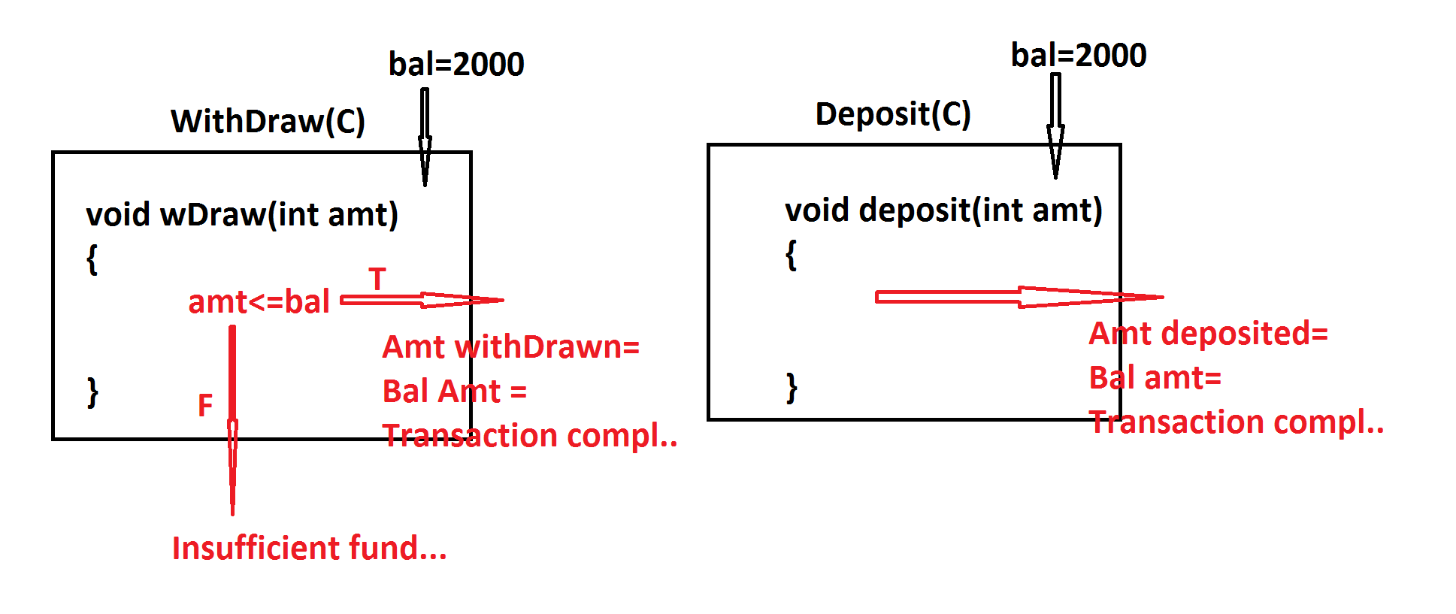

***===========================================================***

***sm.java123@gmail.com***

***=====================================================***

***\*imp***

***define while loop?***

***=>In while looping structure the condition is checked first,if***

***the condition is true then the loop_body is executed and this***

***process is repeated until the condition is false.***

***syntax:***

***while(condition)***

***{***

***//loop_body***

***}***

***FlowChart:***

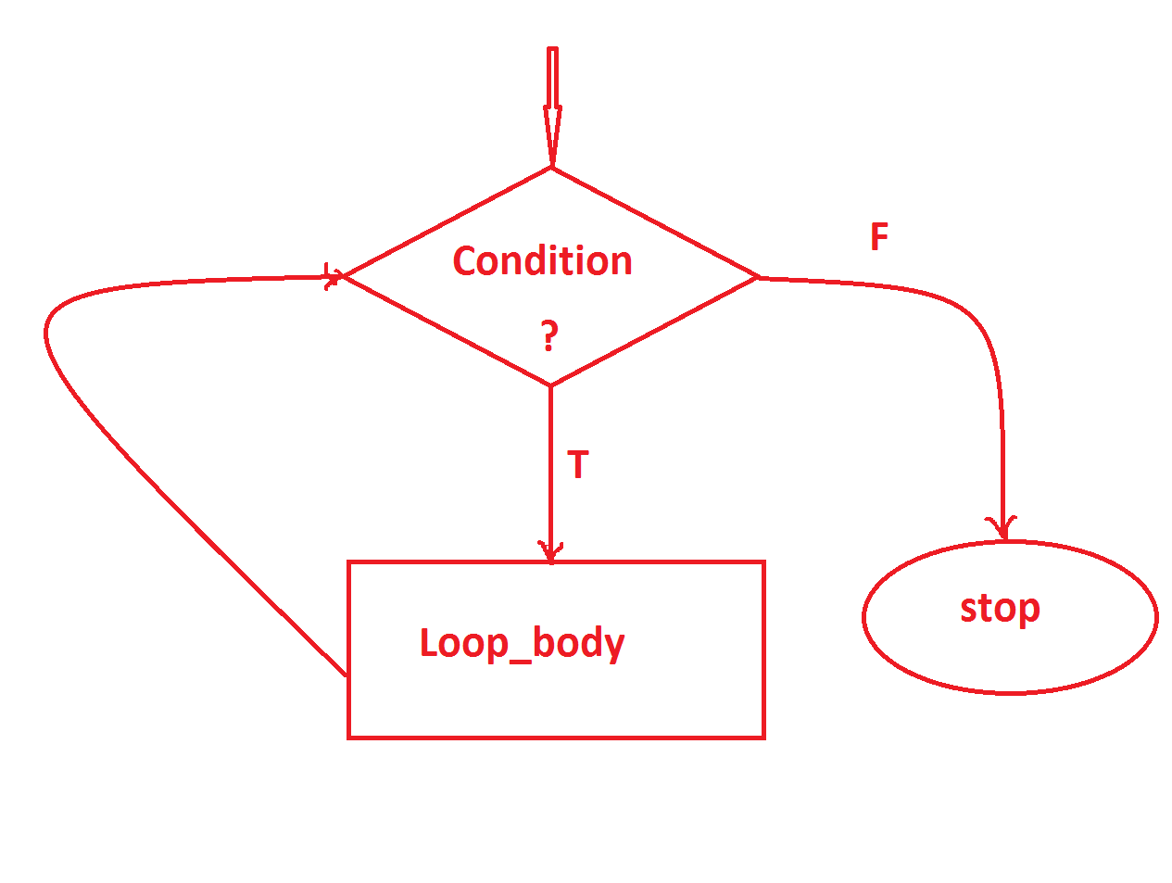

***---------------------------------------------------***

***\*imp***

***define do-while loop?***

***=>In do-while loop the loop_body is executed first and then the***

***condition is checked,this process is repeated until the condition***

***is false.***

***syntax:***

***do***

***{***

***//Loop_body***

***}***

***while(condition);***

***FlowChart:***



